HCS 2100 - Infection and Immunity 3
Exam Review
Name: ____________________
Date: _______________

Part A - Lymphatic System

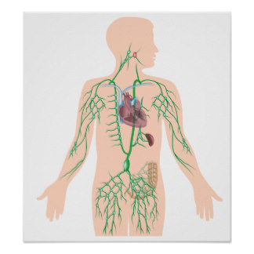
E
D
A
F
B
C

1. Match the following:
____ spleen ____ cervical nodes
____ tonsil ____ inguinal nodes
____ axillary nodes ____ thoracic duct

2. Matching terms:
____ lymph node a) found between the two layers of the peritoneum
____ mesenteric node b) where T cells mature under the influence of
____ thymus thymosin
____ tracheobronchial node c) located near the trachea
d) designed to filter lymph
3. Give 2 functions of the spleen.

4. Give a brief description of the following disorders of the lymphatic system
a) lymphangitis –

b) lymphedema –

c) splenomegaly –

d) lymphoma –

Part B – Immune system
Matching
____ 1. Natural passive immunity
____ 2. Natural active immunity
____ 3. Artificial passive immunity
____ 4. Artificial active immunity
____ 5. Innate immunity
A) Immunity resulting from receiving an antiserum
B) Immunity resulting from recovering from an illness
C) Immunity resulting from receiving a vaccine
D) Immunity resulting from the transfer of antibodies from mother to fetus
E) Immunity resulting from the genetics passed down from your parents

Antibody
Activation of NK cells
Clumping of antigens
Neutralization of toxins
Antigen
Self
Invader
Anaphylaxis
Histamine
phagocyte

6. MHC antigens allow the immune system to identify __________ -antigens.
7. _________________________ is when antibodies link together on antigens forming a cluster that phagocytes can ingest.
8. _______________ is when natural killer cells respond to antibodies attaching to cell surfaces and attack the cell.
9. ____________________ is when antibodies bind to toxin molecules to prevent damage to cells.
10. ____________________ is a life-threatening allergic response that can cause problems with breathing and is treated with injectable epinephrine.
11. Allergic reactions involve an _____________ - antibody reaction.

12. What are 3 negative effects of stress on the immune system?

13. In an allergic reaction, what do sensitized individuals release in excessive amounts?

