Neurons – Self-check Total /25
Name: __________________
Date: _____________

- Label the following neuron.

D
A
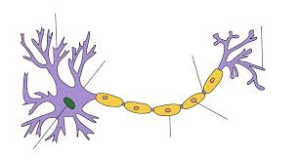
C
B
E
F
G

____ myelin sheath ____ axon
____ nucleus ____ terminal knob
____ cell body ____ node of Ranvier
____ dendrite

- Sensory neurons are also known as _____________ neurons.
- Motor neurons are also known as _____________ neurons.
- Fiber bundles located in the PNS are called _________________.
- Fiber bundles located in the CNS are called _________________.
- Nerves that contain both motor nerve fibers and sensory nerve fibers are called _________ nerves.

/12

Nerve Impulse
- Inside a nerve cell, there is a higher concentration of _____ and outside of the cell there is a higher concentration of _________. This is known as ___________________________.
- A stimulus, which can be chemical or mechanical, can cause _______ to enter the cell and cause ____________________.
- This causes an electrical impulse known as _____________________.
- ________________ follows when _______ channels open allowing _____ to leave.
- When Na+ and K+ concentrations are restored, the nerve cell returns to _________________________.

Myelinated axons
- Myelin is a _______________ that coats some axons.
- This can speed up the nerve impulse because the action potential can ________ from node to node.
- This is called _______________ conduction.

/13

